SafeHer: A Violence Against Women and Children Reporting System With Case Analytics
______________________________

A Capstone Project
Presented to the Faculty
of the College of Information and Communications Technology
Catanduanes State University
Virac, Catanduanes

In Partial Fulfillment of the
Requirements for the Degree
Bachelor of Science in Information Technology

______________________________
Archie T. Taño
Margie G. Araojo
Shiela Mae B. Isorena
Erinea T. Salinas

March, 2026

TABLE OF CONTENTS

TABLE OF CONTENTS ii
LIST OF FIGURES iv
LIST OF TABLES v
CHAPTER 1 1
Project Context 1
Purpose and Description 4
Objectives 7
Scope and Limitations 9
Definition of Terms 12
Conceptual Framework 15
CHAPTER 2 19
Synthesis 24
CHAPTER 3 26
Hardware Requirements 26
Software Requirements 27
Data Requirements 28
User Requirements 31
Discussion of User Requirements 33
CHAPTER 4 34
Requirements Analysis 35
Requirements Documentation 38
Design of Software, Systems, Product and/or Processes 43
Development and Testing 62
Data Gathering Procedure 66
Respondents of the Study 69
Statistical Tool 70
REFERENCES 73
A. Books 73
B. Journals/Conferences 73
C. Websites 74
D. Other Sources 74

LIST OF FIGURES
Figure 2. Context Diagram of the SafeHer System 44
Figure 3. Data Flow Diagram of the SafeHer Case Management Process 45
Figure 4. Use Case Diagram of SafeHer System Actors and Functions 46
Figure 5. Process Swimlane Diagram of the Reporting and Referral Workflow 47
Figure 6. Entity-Relationship Diagram (ERD) of the SafeHer Database 48
Figure 7. System Architecture of the SafeHer Web and SMS Platform 49
Figure 8. Complainant Storyboard 50
Figure 9. VAWC Storyboard 51
Figure 10. Barangay Staff Storyboard 51
Figure 11. System Administrator Storyboard 52
Figure 12. User Login 54
Figure 13. User Registration 55
Figure 14. User Dashboard 56
Figure 15. Incident Report 57
Figure 16 Case Assignment 58
Figure 17. SMS Information 59
Figure 18. Escalation Management 60
Figure 19. Feedback Management 61

LIST OF TABLES
Table 1. Hardware Requirements 26
Table 2. Software Requirements 27
Table 3. Data Requirements 28
Table 4. Respondents of the Study 69

CHAPTER 1
INTRODUCTION

Project Context
In the world people live in today, there are things that cannot be avoided, and one of these is the occurrence of violence against women and children. This form of abuse remains one of the most serious issues facing not only the Philippines but the entire world. Many women and children suffer from physical, emotional, and psychological abuse from their own family members or partners. According to various studies, violence against women and children continues to rise in different parts of the country, and the victims often find it difficult to ask for help because of fear, shame, and the worry that their abusers might take revenge if they speak out.
This issue of Violence Against Women and Children (VAWC) is not just a national problem but also a major challenge for local governments, especially in the province of Catanduanes. Based on data from the Catanduanes Police Provincial Office, although the total number of VAWC cases in the province slightly decreased from 158 in 2024 to 143 in 2025, the municipality of Virac remains the primary area where incidents of violence are high. According to reports from Radyo Pilipinas Virac and the Catanduanes Tribune, Virac has the most VAWC cases in the entire province with 47 incidents recorded in 2025 alone. This data aligns with earlier records from the first half of 2024 where Virac alone had 39 cases in just six months representing 58 percent of the total cases in the entire province. Furthermore, records from the Provincial Prosecutor's Office show that up to 750 individual abuse charges have been filed in the courts in Virac, pointing to a recurring cycle of violence against local victims.
This problem is deeply felt at the community level, particularly in target areas like Barangay Gogon Centro. Despite these alarming numbers, the current system of reporting and tracking cases remains outdated and inefficient, causing slow response to the victims. The victims face severe emotional challenges such as fear of being judged by others, pressure from their families, and the risk of retaliation from their abusers if they personally go to the barangay hall to report an incident. This situation becomes even more dangerous in close-knit communities like Gogon Centro, where abusers often keep a close watch on their victims, making a physical trip to the authorities not only intimidating but potentially life-threatening for the victim.
Another major obstacle is the strict confidentiality policy mandated by the Anti-VAWC Act (RA 9262), which requires that detailed records of cases be carefully kept by the Municipal Social Welfare and Development Office (MSWDO) and the police's Women and Children Protection Desk (WCPD). However, because these records are still stored in physical paper logbooks, fast coordination between different agencies becomes difficult. Relying on paper trails and forcing victims to report in person creates a significant communication gap, leaving victims uninformed about the progress of their cases and significantly delaying the deployment of local protection exactly when they need it the most.
To address these challenges, the researchers are developing a system called SafeHer a web-based VAWC Reporting and Case Tracking System designed to make the process of reporting, referral, and case monitoring smoother, faster, and safer. This system will have built-in SMS notification capabilities and a Barangay Response Management feature aimed at speeding up and clarifying coordination between officials and agencies. The main value of SafeHer is that it brings the reporting process online while strictly following the privacy rules of the Anti-VAWC Act (RA 9262) through role-based security. The system serves as a secure central hub where victims or concerned citizens can submit reports and upload digital evidence without risking their safety. Through automated text alerts, the system instantly connects the VAWC desk, and barangay officials to ensure a fast and effective response.
SafeHer is designed to make reporting less overwhelming for victims, help local responders act quickly, and maintain a secure digital record that will guide leaders in making better decisions. This project aligns with Sustainable Development Goal number 5 (Gender Equality) because it aims to combat violence against women and children, and SDG number 16 (Peace, Justice, and Strong Institutions) by promoting effective, accountable, and inclusive institutions.
The implementation and testing of this project will take place specifically in Barangay Gogon Centro, Virac, Catanduanes, focusing on the local community and its enforcement setup. This location was chosen because it has the highest concentration of VAWC cases in the entire province, making it the ideal site for initial deployment and impact measurement. Starting in just one barangay allows the researchers to closely monitor the system's performance, user adoption, and response times in a real-world setting before expanding it to other barangays in the municipality.
The target users of the system fall into four main groups: the Complainants or Victims who need a secure and confidential way to report and track their cases, the Barangay Captain and Barangay Staff who review and process incoming complaints while ensuring compliance with confidentiality protocols, the Barangay Responders in Gogon Centro who receive validated reports and deploy immediate action and protection; and the System Administrator who manages system security, user access, and monitors the analytics dashboard for reporting and decision-making.
SafeHer strictly focuses on receiving digital reports, securely tracking case progress, sending automated SMS alerts, and routing important information between agencies. The system is designed to augment not replace active police fieldwork, official court proceedings, or physical intervention efforts. It serves as a technological bridge that enhances coordination and ensures that no victim falls through the cracks due to outdated communication methods.
Relying on manual and paper-based tracking is no longer practical or safe for a community like Barangay Gogon Centro, which handles a significant portion of the province's VAWC cases. By bringing in SafeHer, the community gains a modern and responsive tool that completely changes how local leaders handle gender-based violence. The system's ability to provide secure and remote reporting encourages more victims to come forward safely, while the digital record ensures that the barangay desk remains accountable for how quickly they respond. SafeHer moves Gogon Centro toward a more transparent, secure, and proactive environment one that offers stronger and more reliable protection for women and children against ongoing abuse.

Purpose and Description
The primary purpose of SafeHer is to provide a secure, accessible, and centralized digital platform for managing incidents of Violence Against Women and Children (VAWC). The project aims to bridge the gap between vulnerable individuals and local authorities by transforming the traditional, manual reporting process into a more efficient and modern web-based system. With SafeHer, victims and concerned citizens can seek help and coordinate with authorities without the need for intimidating and often dangerous physical visits to the barangay hall or police station. The system is designed to make the reporting process less overwhelming by allowing users to submit complaints and upload evidence from the safety of their own homes or any location where they feel secure. By doing so, SafeHer significantly reduces the emotional and logistical barriers that have long prevented victims from coming forward. The system also ensures that every case is handled with urgency, proper documentation, and the highest level of discretion, guaranteeing that sensitive information remains protected and that victims receive the timely support and protection they deserve.

Objectives
The main objective of this project is to design and develop SafeHer, a web-based reporting, referral, and case tracking system equipped with SMS notifications. Its primary purpose is to provide a centralized, secure, and efficient platform that streamlines the reporting and management of Violence Against Women and Children (VAWC) incidents. The system is specifically designed for the benefit of complainants/victims who need a safe and accessible reporting channel, as well as VAWC personnel and local barangay officials who require reliable tools for case coordination, validation, and monitoring.
Specifically, the objectives are the following:
- To develop a Violence Against Women and Children Reporting System that operates securely online, allowing victims to submit complaints and attach digital evidence without leaving their homes or visiting the barangay hall in person.
- Implement case analytics for local leaders and administrators to easily monitor safety trends. The system will feature a visual dashboard that summarizes reported incidents, helping officials in Barangay Gogon Centro and the municipality make data-driven decisions to prevent future abuse and assign resources where they are needed most.
- Integrate SMS Notification for keeping everyone instantly informed without requiring a constant internet connection. By integrating the PhilSMS Gateway, the system will automatically send text message updates to victims about their case progress.
- To evaluate the system and find areas for improvement, the researchers will analyze system response times and user feedback using the ISO/IEC 25010 software quality standard.
- Functional Suitability
- Performance Efficiency
- Compatibility
- Usability
- Reliability
- Security
- Maintainability
- Portability
- Safety
Scope and Limitations
This project focuses on developing SafeHer, a web‑based VAWC reporting system specifically designed for Barangay Gogon Centro, Virac, Catanduanes. The system will be built with integrated SMS capabilities to send automated alerts to both victims and local responders. The platform will provide a secure online space where victims or concerned citizens can submit incident reports and upload digital evidence, which will then trigger instant notifications to the Municipal Social Welfare and Development Office (MSWDO), the Women and Children Protection Desk (WCPD), and barangay officials to ensure a prompt and coordinated response. Additionally, the system will include an analytics and management dashboard that allows authorized responders to log, validate, track, and refer VAWC cases, providing real‑time updates on case statuses so that complainants can safely monitor the progress of their reports from any location.
However, the project has several limitations that must be clearly defined. First, SafeHer will strictly function as a digital reporting and case tracking tool, meaning it cannot physically stop an ongoing replace emergency hotlines like 911 during life threatening situations. The system will rely on a stable internet connection and cellular network availability for sending reports and receiving automated text updates, so areas with poor connectivity may experience delays. The platform will be designed as a responsive web application accessible through standard web browsers and will not include a downloadable mobile application for Android or iOS devices. The dashboard for municipal and barangay responders will be designed to log, validate, and track VAWC cases, but it will not include advanced features or direct integration with other local government databases or the national police system. Furthermore, while the system will send automated SMS alerts to victims and assigned responders, it will not be designed to handle mass notifications or large‑scale community broadcasts. The project will focus solely on the development, testing, and functionality of the SafeHer system within Barangay Gogon Centro, and it will not include long‑term server maintenance, post‑launch technical support, or expansion to other barangays beyond the initial deployment site.

Definition of Terms
To ensure a clear understanding of the key concepts used in this study, the following terms are defined based on their relevance to the research context:
Barangay Response Management - Refers to the system module that allows local barangay officials in Virac to receive forwarded complaints, log their on-the-ground interventions, and update the resolution status of a case.
Case Tracking - Refers to the capability of the system to monitor the real-time progress of a reported incident across different stages (e.g., Pending, Validated, Referred, Ongoing, Resolved).
Case Analytics - refers to the feature of the system that generates reports and insights from collected VAWC data to help local leaders make informed decisions.
Complainant - refers to the system user who has experienced or witnessed abuse and utilizes the platform to submit an incident report, upload digital evidence, and monitor their case status.
Compatibility - the web-based platform should work seamlessly across different browsers, operating systems, and devices, while the SMS feature must function reliably across major cellular networks.
Flexibility - the system should be adaptable to accommodate additional barangays, customize reporting forms, and handle various types of VAWC cases as the needs of the community evolve over time.
Functional Suitability - SafeHer must accurately perform its core functions, including accepting digital reports, uploading evidence, sending automated SMS alerts, and tracking case statuses to ensure that all features work as intended for victims and responders.
ISO/IEC 25010 - A standardized software quality model utilized by the researchers to evaluate the system’s functional suitability, usability, security, and reliability through expert and user testing.
Interaction Capability - SafeHer must provide an intuitive and user-friendly interface that allows victims, responders, and administrators to easily navigate the system and communicate effectively with one another.
JavaScript - A programming language utilized in the development of the project to create dynamic and interactive front-end user interfaces, ensuring the platform is highly responsive for the victims and administrators.
Laravel PHP Framework - The primary backend software technology used to build the logic, database routing, and overall architecture of the SafeHer application.
Maintainability - the system must be structured in a way that allows developers to easily update features, fix bugs, and add improvements without disrupting its overall functionality.
MySQL - The relational database management system used by the application to securely store, organize, and retrieve all user records, submitted evidence, case details, and system audit logs.
PhilSMS Gateway API (Application Programming Interface) - The specific third-party service integrated into the system’s code to automatically bridge the web application to local telecommunication networks, enabling the sending of text messages.
Performance Efficiency - SafeHer should respond quickly to user actions, process report submissions without delays, and send SMS notifications within seconds to ensure that help reaches victims as fast as possible.
Reliability - the system must operate consistently without crashes or data loss, ensuring that reports are always available and accessible whenever victims need to submit complaints or responders need to take action.
SMS (Short Message Service) Notification - Refers to the automated text message alerts generated by the system to inform victims of their case updates and to notify responding personnel of new assignments without requiring internet access on the receiver's end.
System Administrator - Refers to the authorized IT personnel responsible for maintaining the system’s backend, managing user accounts, configuring system settings, and ensuring data security.
Safety - SafeHer must prioritize victim protection by ensuring discreet communication, preventing exposure of sensitive information, and enabling prompt response from authorities to prevent further harm.
Security - SafeHer must enforce strict role-based access controls and data encryption to protect sensitive victim information and ensure that only authorized personnel can view or modify case records.
Validation - Refers to the process conducted by authorized VAWC staff to review submitted online reports and uploaded evidence to determine their legitimacy before officially forwarding them to the barangay desk.
VAWC (Violence Against Women and Children) - Refers to the specific category of abuse incidents, defined under Republic Act No. 9262, that the system is built to record, track, and manage.
WCPD (Women and Children Protection Desk) - The specialized unit of the Philippine National Police in Virac that coordinates within the system for reported cases requiring immediate law enforcement intervention.
Web-Based Application: - Refers to the software architecture of SafeHer, meaning the platform is accessed over a network connection using an internet browser rather than requiring a physical installation on the user's local device.
XAMPP (Cross-Platform, Apache, MariaDB, PHP, and Perl) - The local server environment utilized by the researchers during the development phase to test the PHP code and MySQL database before deploying the system online.

Conceptual Framework
The conceptual framework of this study is anchored on the Input-Process-Output (IPO) model, which visually and descriptively illustrates the flow of the research and the interaction of the project's key variables. This paradigm maps out the necessary requirements needed to build the system, the development and operational phases to be carried out, and the expected final product and its impact on the community, ultimately guiding the researchers in achieving the study's objective of streamlining VAWC reporting and response in Barangay Gogon Sirangan, Virac, Catanduanes.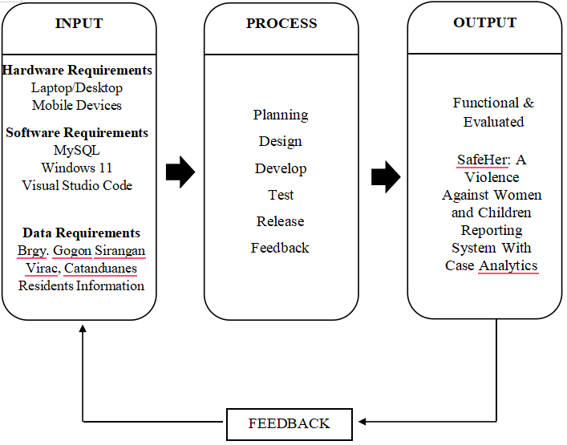
Centro
Figure 1. Conceptual Framework
The IPO model illustrates the flow of requirements, processes, and outcomes involved in the development of SafeHer. The Input section identifies the resources needed to build the system, including hardware such as laptops, desktops, and mobile devices for accessing the platform software tools for development and database management; and data requirements which include information about residents of Barangay Gogon Centro, Virac, Catanduanes who will serve as the primary users and beneficiaries of the system. The Process section outlines the step-by-step approach in creating SafeHer, starting from planning where the researchers define the system goals and features, followed by design where the user interface and database structure are created, then development where the actual coding and implementation take place, testing to ensure the system functions correctly and meets user needs, release for deployment to the target barangay, and feedback to gather user input for further improvements. The Output of this entire process is a Functional and Evaluated SafeHer system a web-based Violence Against Women and Children Reporting System with Case Analytics that is ready for use by the community of Barangay Gogon Centro. This model provides a clear and easy to understand overview of how the project will be carried out from start to finish, ensuring that all necessary requirements are considered and that the development process follows a structured and systematic approach.

CHAPTER 2
REVIEW OF RELATED LITERATURE/SYSTEMS

This chapter reviews related literature, studies, and technologies that support the development of SafeHer. It explores the use of digital platforms, SMS notifications, and quality evaluation methods in improving public safety services. Through this review, the chapter discusses the advantages of adopting technology in government processes and points out the current gaps in handling VAWC reporting and case management.
Legal Bases and Mandates for VAWC
The fight against violence against women and children is anchored on various legal frameworks that provide protection and support for victims. In the Philippines, the most significant legislation addressing this issue is the Anti-Violence Against Women and Their Children Act of 2004, also known as Republic Act No. 9262. This law protects women and children from physical, sexual, psychological, and economic abuse committed by their husbands, partners, or former partners. It also provides for the issuance of protection orders, such as Barangay Protection Orders (BPOs), Temporary Protection Orders (TPOs), and Permanent Protection Orders (PPOs), to ensure the safety of victims. The law mandates the creation of mechanisms for reporting and responding to cases of abuse, including the establishment of Women and Children Protection Desks (WCPD) in every police station and the designation of VAW desks in every barangay.
According to the study of Caparas S. & Amparado O. (2012), Republic Act No. 9262 provides the legal framework for addressing violence against women and children in the Philippines. The study assessed the awareness of 96 women in Village Looc, Mandaue City regarding the Anti-Violence against Women and their Children Law, using a descriptive-correlational design. Most respondents were 25-65 years old, single with a live-in partner, had 0-3 children, were high school graduates, and belonged to the low-income bracket. The study found that television was the primary source of awareness about intimate partner violence, and most respondents were aware of RA 9262. A significant relationship was established between Information, Education and Communication (IEC) modes and the level of awareness, concluding that full awareness through IEC is necessary to ensure the protection of women and children. This aligns with SafeHer's goal of providing accessible information and reporting mechanisms for victims in Barangay Gogon Centro, ensuring that awareness of the law translates into concrete action and protection for those in need.
Furthermore, the study of Balahadia, Astoveza, and Jamolin (2022) analyzed VAWC cases in the province of Laguna to determine the level of law awareness, reasons for unreported incidents, and preferences for reporting mechanisms. Using descriptive statistics and Kruskal Wallis with 356 respondents, the study found that emotional abuse was the most commonly witnessed type of violence, while physical abuse was the most commonly experienced, often perpetrated by former husbands. Despite respondents being "Very Aware" of RA 9262, 70.5% did not report cases due to embarrassment, fear of blame, inability to make decisions, and fear of societal judgment. The study also revealed that most respondents believed a mobile application or website could help in reporting abuse, highlighting the potential of digital platforms in addressing the reporting gap. These findings align with the situation in Barangay Gogon Centro, where victims face similar barriers to reporting, and where SafeHer aims to provide a secure online platform with SMS notifications and real-time case tracking to encourage victims to come forward safely.
In addition, the study of Bernal (2017) examined the level of awareness of respondents to the Anti-Violence against Women and their Children Act of 2004 according to age, civil status, educational attainment and length of service, finding that while awareness and advocacy vary across demographics, actualization remained consistently "high" across all groups. The study revealed significant differences between awareness and advocacy, and between awareness and actualization, emphasizing that knowing the law does not automatically translate into action. The researcher recommended intensified trainings, inclusion of RA 9262 in educational curricula, and exhaustive information dissemination to bridge the gap between awareness and actualization. These findings directly relate to Barangay Gogon Centro, where despite awareness of RA 9262, victims still hesitate to report abuse and barangay personnel lack digital tools for proper case management. SafeHer addresses this gap by providing a secure online reporting platform with SMS notifications and real-time case tracking, ensuring that legal awareness translates into concrete protection and accessible services for victims.
Moreover, the study of Rivano and Rivano (2022) assessed the cases of domestic violence against women in selected barangays in the Municipality of Santa Cruz, Laguna, Philippines and developed an action plan to enhance the VAW services of the barangays. The study utilized the descriptive-qualitative research method where documentary analysis and respondent interviews were used to gather data, with subjects including victims and survivors from ten selected barangays and involvement of officials from MSWD, Municipal Police Unit, and barangay officials such as the barangay captain, secretary, health workers, public safety officers, and VAW Desk officers. Results showed that physical abuse is the most common recorded case, followed by psychological abuse, threatening, abandonment of children, child support issues, child custody, and economic abuse, with causes rooted in the perpetrator's dependence on illegal drugs, jealousy, presence of a third party, alcohol influence, unemployment, and provocation from the intimate partner. While barangay respondents provide services in compliance with the Magna Carta of Women and RA 9262, certain conditions and challenges were observed, highlighting the need for enhanced barangay-level action plans. This directly relates to the situation in Barangay Gogon Centro, where similar challenges exist despite the legal mandates, and where the current reporting system remains outdated and reliant on physical paper logbooks, making coordination between barangay officials slow and difficult. The study's recommendation for enhanced action plans and better documentation supports the development of SafeHer, a web-based system designed to provide secure online reporting, real-time case tracking, automated SMS notifications, and coordinated inter-agency response addressing the very gaps identified in the Laguna study and helping barangays fulfill their mandates under RA 9262 more effectively.
Technological Architecture and Infrastructure
The effective handling of VAWC cases requires a well-coordinated case management and reporting system supported by appropriate technological infrastructure. Various local government units in the Philippines have implemented digital platforms that leverage unified databases, real-time case tracking, and secure data management to enhance coordination among agencies and improve service delivery for victims. However, studies have revealed persistent gaps in equipment, resources, and capacity at the barangay level that hinder the full functionality of VAW desks, highlighting the need for accessible and user-friendly digital solutions like SafeHer.
The study of Consignado C.G et al. (2022), a multi-level assessment of community-based VAW desks in Calamba City, Laguna, examined the VAW system, desk setup, and desk officers' capacities through surveys and interviews with 105 officers and five local officials. While policies on establishing barangay VAW desks were properly enforced, the study found a lack of equipment and resources, unclear qualifications for desk officers, and no proper orientation system for their roles and responsibilities. The researchers recommended policy amendments, capacity-building, proper fund allocation, and a strengthened feedback system with rewards and penalties. These findings mirror the situation in Barangay Gogon Centro, where similar resource and capacity gaps hinder effective VAWC response. SafeHer addresses these challenges by providing a digital platform that is accessible and user-friendly, requiring minimal equipment or technical expertise from desk officers, while serving as a tool for reporting, tracking, and coordinating VAWC cases.
Furthermore, the study of Pablo M. & Dalugdog A. (2025) determined the capability and challenges of barangay VAWC desk officers in the province of Laguna using a descriptive research design with a survey questionnaire distributed to 214 respondents. The study revealed that VAWC desk officers are extremely capable in the execution of intermediate functions, but only capable in implementing immediate interventions and anti-VAW prevention functions. The challenges encountered by the desk officers were found to be moderately serious in the implementation of immediate intervention, execution of immediate functions, and implementation of anti-VAW prevention. The study also concluded that the age profile of desk officers has a significant relationship to the challenges they encounter in performing their duties. These findings highlight that even when desk officers possess capability, they still face barriers that limit their effectiveness. SafeHer can address these challenges by providing a digital platform that streamlines reporting and case management, reducing the burden on desk officers and enabling them to focus on providing immediate interventions and prevention programs, while also serving as a tool for capacity-building and inter-agency coordination.
In addition, the study of Mendoza D. (2025) examined the correlation between the profile of barangay VAWC desk officers including age, educational attainment, years of experience, and training hours and their role performance in relation to the service efficiency of barangay VAWC desks in four municipalities in Laguna. Using a descriptive quantitative research design with 99 respondents, the study found that barangay VAWC officers are mostly middle-aged, have completed secondary education or some college, and have limited experience and training. While their role performance and service efficiency were both rated very high, only specific aspects of role performance, such as confidentiality, case documentation, and abuse interventions, significantly correlated with service outcomes. However, the overall findings indicated no significant general relationship between role performance and service efficiency, and while certain profile attributes influenced particular performance dimensions, these effects were not widespread or uniform. The study recommended continuous training for officers, stronger inter-agency collaboration, and further research into other potential determinants of VAWC desk service efficiency. This supports the development of SafeHer, as the system can serve as a tool for continuous training, standardized documentation, and enhanced inter-agency collaboration, addressing the gaps identified in the study and ensuring that desk officers can perform their roles more effectively regardless of their demographic profiles.

System Evaluation Framework and Quality Standards
The evaluation of SafeHer is guided by the ISO/IEC 25010 standard, which provides a comprehensive framework for assessing the quality of software systems. This standard defines various quality characteristics that are essential for ensuring that software systems meet user needs and perform effectively in their intended environment. Various studies have applied this framework to evaluate Philippine information systems, providing valuable benchmarks for the assessment of SafeHer. As highlighted in the study of Mendoza (2025) and other studies, barangay VAWC desk officers face challenges in service efficiency despite high role performance ratings, suggesting the need for digital tools that are evaluated against quality standards to ensure they effectively support frontline responders.
Based on the study of Renz B. (2026), the Barangay Governance Information System (BAGIS) was developed and validated for administrative operations in four barangays in Surigao del Norte. Using a developmental research design and evaluated using ISO/IEC 25010:2023 criteria, BAGIS obtained an overall expert validation mean of 4.60 (very high) and user acceptability mean of 4.42 (high), with security and functionality receiving the highest ratings. The study concluded that BAGIS is a functional, acceptable, and validated digital system that supports organized records, faster transactions, and efficient reporting in barangay operations. This aligns with SafeHer, which similarly aims to provide a validated digital platform for barangay-level VAWC reporting and case management, ensuring that the system meets quality standards in terms of functionality, usability, security, and reliability.
In addition, the study of Fernandez (2026) examined the relationship between barangay officials' level of understanding of the CY 2024 Seal of Good Local Governance for Barangays (SGLGB) assessment criteria and their corresponding assessment results in the municipalities of Santa Cruz and Pakil, Laguna. Using a quantitative-correlational research design involving 384 barangay officials, the study found that while respondents demonstrated a high level of understanding across all governance areas, most relationships between understanding and actual SGLGB performance were not statistically significant. Notably, Financial Administration and Sustainability had the lowest compliance rate despite being well-understood, while Business-Friendliness and Competitiveness had the highest compliance despite being the least understood. The study concluded that awareness of SGLGB criteria alone may not be enough to ensure high-level performance, as institutional, structural, and implementation-related factors also play a crucial role. The findings emphasized the need to bridge the gap between knowledge and actual implementation through strengthened capacity-building programs by the DILG, enhancement of the Barangay Information Management System (BIMS), and sufficient institutional support. This aligns with the development of SafeHer, as the system can serve as a tool for bridging the gap between knowledge and action by providing barangay officials with a user-friendly digital platform that streamlines reporting, case tracking, and documentation ensuring that understanding of VAWC protocols translates into effective implementation and improved service delivery for victims.
Moreover, the study of Dela Cerna (2023) developed and implemented an office automation system for Barangay Local Government Units designed to foster digital empowerment. The system aimed to automate the laborious barangay transaction processing procedure, simplifying administrative activities such as requesting documents, filing complaints, and producing accurate and thorough reports. The system was built using an extreme programming approach, focusing on the design and testing of system features, graphical user interfaces, and database administration. The system successfully created nine fully functional components that may help the delivery of effective and efficient public services. The researcher advocated that the system be adopted by other barangays and tailored following the BLGU's process flow. This study supports the development of SafeHer, as it demonstrates the effectiveness of office automation systems in streamlining barangay administrative processes, including complaint filing and report generation—core functions that SafeHer aims to provide for VAWC reporting and case management in Barangay Gogon Centro.
Furthermore, the study of Dandan A. et al. (2026) evaluated the effectiveness of the Barangay Management System (BMS) developed for Barangay Macapso, Vallehermoso, Negros Oriental, Philippines. Using a descriptive developmental research design, the study assessed the system through end-user surveys and IT expert evaluations based on the ISO/IEC 25010:2011 software quality model. The findings revealed that end-users rated the system highly in functional suitability, usability, reliability, and performance efficiency, while IT experts reported favorable results for maintainability, compatibility, and security. The results indicated that the BMS effectively supports operational tasks, enhances service delivery, and meets essential software quality standards. Gaps identified included varying digital proficiency among users and areas for ongoing system optimization. The study recommended targeted user training, continuous system maintenance, and potential expansion to other barangays to ensure scalability and sustained adoption. These findings reinforce the value of ISO 25010-based evaluations in ensuring that barangay-level information systems are functional, reliable, and user-friendly. This directly supports the development of SafeHer, as it demonstrates that a web-based platform evaluated using established quality standards can effectively support barangay administrative operations and service delivery, while also highlighting the importance of user training and continuous improvement to ensure sustained adoption and effectiveness in Barangay Gogon Centro.

Synthesis
The reviewed literature and studies across the three thematic areas Legal Bases and Mandates for VAWC, Technological Architecture and Infrastructure, and System Evaluation Framework and Quality Standards provide a comprehensive foundation for the development of SafeHer. These studies collectively highlight the persistent gaps in VAWC reporting and case management at the barangay level, while also demonstrating the potential of digital platforms to address these challenges.
In Barangay Gogon Centro, Virac, Catanduanes, the high number of VAWC cases is compounded by an outdated reporting system that relies on physical paper logbooks, making coordination between barangay officials, MSWDO, and WCPD slow and difficult. The studies of Caparas and Amparado (2012), Balahadia, Astoveza, and Jamolin (2022), and Bernal (2017) all revealed that while awareness of RA 9262 exists among women, a significant gap remains between knowing the law and taking action 70.5% of victims do not report abuse due to fear, shame, and societal judgment. This aligns with the situation in Barangay Gogon Centro, where victims face similar barriers, highlighting the urgent need for alternative reporting mechanisms.
The studies under Technological Architecture and Infrastructure Consignado, Amparo, and Alampay (2022), Pablo and Dalugdog (2025), and Mendoza (2025) further revealed persistent gaps in equipment, resources, and capacity at the barangay level that hinder the full functionality of VAW desks. Despite barangay officials providing services in compliance with RA 9262 and the Magna Carta of Women, challenges in documentation, coordination, and resource allocation remain. These findings directly mirror the situation in Barangay Gogon Centro, where the current system relies on manual processes that delay response and leave victims uninformed. SafeHer addresses these gaps by providing a centralized digital platform that streamlines reporting, automates notifications, and enables real-time case tracking reducing the burden on desk officers and ensuring that victims receive timely support.
The System Evaluation Framework and Quality Standards studies Buctuan (2026), Fernandez (2026), Dela Cerna (2023), and Dandan et al. (2026) demonstrate that barangay-level information systems evaluated using ISO/IEC 25010 standards can effectively support administrative operations and service delivery. These studies consistently showed that web-based platforms with strong functional suitability, usability, reliability, and security receive high user acceptability and expert validation ratings. This reinforces the approach taken in SafeHer, which will be evaluated using the same ISO 25010 quality characteristics to ensure that the system meets user needs and performs effectively in its intended environment.
The novelty of SafeHer lies in its unique integration of secure online reporting, automated SMS notifications, case analytics, and real-time case tracking into a single web-based platform specifically designed for barangay-level VAWC management. Unlike existing barangay systems that focus on general administrative functions, SafeHer is purpose-built for the sensitive nature of VAWC cases, incorporating role-based security to ensure that only authorized personnel can access victim information, and a case analytics dashboard that enables barangay officials and local leaders to monitor safety trends and make data-driven decisions. Furthermore, the integration of SMS notifications ensures that victims receive real-time updates on their case progress even without internet access, while barangay responders are instantly alerted to new reports features that are currently absent in the manual paper-based system used in Barangay Gogon Centro. By combining these features into a single, user-friendly platform, SafeHer provides a comprehensive solution that addresses the legal, technological, and quality gaps identified in the literature, ensuring that victims can report abuse safely and that barangay officials can respond promptly and effectively. This study builds upon the findings of previous research while offering a practical, technology-driven solution to address the pressing issue of violence against women and children in the community.

CHAPTER 3
TECHNICAL BACKGROUND
This chapter discusses the comprehensive technical requirements necessary for the development, implementation, and operation of the SafeHer system. It details the specific hardware devices, processing capabilities, and network infrastructure required to ensure the system functions optimally. The specifications outlined in this chapter are carefully selected to support the web-based architecture, database management, and SMS Gateway integration of the project, ensuring a seamless experience for developers, administrators, and end-users.

Hardware Requirements
This section specifies the physical devices and equipment required to develop the system and the minimum hardware necessary for the target users to access the platform. The requirements are divided into the development/server needs and the end-user requirements.
Table 1. Hardware Requirements
Hardware Requirement | Specification | Description
Computer/Laptop | Processor: Intel Core i5 or AMD Ryzen 5 (Minimum) | Serves as the primary machine used by the researchers to code the system, run the XAMPP local server, and compile the Laravel framework.
Hardware Requirement | Specification | Description
Storage Drive | 256 GB Solid State Drive (SSD) | Provides fast data read and write speeds, which are essential for database queries and storing system assets and uploaded digital evidence.
Network Device | Broadband Router or Mobile Data capable device | Necessary to connect the devices to the internet for system access and to communicate with the PhilSMS Gateway API.

Software Requirements
This section outlines the specific software applications, programming languages, and third-party services required to develop, test, and run the SafeHer system. These tools encompass the development environment utilized by the researchers, as well as the software needed by the end-users to interact with the web-based platform.
Table 2. Software Requirements
Software Requirement | Specification | Description
Local Server Environment | XAMPP (Apache, MYSQL, PHP) | Used to simulate a live web server on the local machine, allowing the researchers to test the database and PHP scripts offline.
Programming Language | Laravel (PHP Framework) | The core software framework utilized to build the system's backend architecture, data routing, and server-side logic securely and efficiently.
Frontend Technologies | HTML5, CSS3, JavaScript | The programming languages used to design the user interface, ensuring the web application is interactive, accessible, and mobile-responsive.
Software Requirement | Specification | Description
Integrated Development Environment (IDE) | Visual Studio Code (VS Code) | The primary code editor used by the developers to write, edit, and debug the source code of the project.
Web Browser | Google Chrome, Mozilla Firefox, Safari, or Microsoft Edge | The client-side software required by all users (victims, MSWDO, WCPD, barangay officials) to access and navigate the web-based system.

Data Requirements
This section outlines the specific data needed to complete the SafeHer project. It details the constructs being measured, the sources of the data, the techniques and instruments used for gathering, and how the collected data will be processed to achieve the study's specific objectives.
Table 3. Data Requirements
Construct/ Variables | Source of Data | Data Gathering Technique | Instrument | Data Processing
Operational Protocols and System Requirements (Current VAWC procedures, necessary features, and routing rules) | Barangay Officials in Virac | Key Informant Interview & Document Review | Interview Guide & Existing manual VAWC intake forms/logbooks | Thematic Analysis and Requirements Mapping
System Quality Evaluation (Functional Suitability, Security, Reliability) | IT Professionals and Technical Experts | System Testing & Survey Administration | ISO/IEC 25010-based Evaluation Questionnaire (Likert Scale) | Statistical Analysis (Weighted Mean)
Construct/ Variables | Source of Data | Data Gathering Technique | Instrument | Data Processing
User Experience Evaluation (Usability and Functional Suitability) | Targeted End-Users Barangay Officials, and Citizen/Victim representatives) | Alpha/Beta Testing & Survey Administration | ISO/IEC 25010-based Evaluation Questionnaire (Likert Scale) | Statistical Analysis (Weighted Mean)

To ensure the system actually fits the community's needs, the researchers must first gather qualitative data on how VAWC cases are currently handled in Virac. By interviewing the Barangay Officials and reviewing their physical logbooks, the developers can map out the exact database structure, user roles, and case-routing rules that need to be coded into the Laravel backend.
To fulfill the second specific objective of evaluating the system, quantitative data must be gathered from IT Professionals. The specific constructs measured here are the technical characteristics of the ISO/IEC 25010 model, namely Functional Suitability, Security, and Reliability. After allowing the IT experts to rigorously test the system (Data Gathering Technique), an ISO/IEC 25010-based questionnaire utilizing a 5-point Likert Scale will be administered as the primary instrument. The data gathered will be processed using descriptive statistics, specifically computing the Weighted Mean, to mathematically determine if the system's codebase, database security, and SMS API integration meet industry standards.
Similarly, the usability and practical functional suitability of the system must be evaluated by the actual target users, which include the barangay staff, and a sample of local citizens acting as potential complainants. After conducting alpha and beta testing sessions where users interact with the live platform, they will answer a customized ISO/IEC 25010-based survey. The results from this instrument will also be processed via Weighted Mean. This processed data is highly relevant to the project's success, as it dictates whether the user interface is intuitive enough for a victim in distress to navigate, and whether local government units can efficiently operate the dashboard without extensive technical training.

User Requirements
This section details the essential modules, functions, and features that the SafeHer system must include to comprehensively meet the needs of its target users. It outlines the core functionalities such as user management, data handling, reporting, notifications, and security measures designed to support the specific roles of the Complainant/Victim, , Barangay Captain and Barangay Staff.

Table 4. User Requirements
Module | Function | Description | User Role
Dashboard | Overview of System Status | Displays key case metrics, active alerts, statistical charts, and summaries tailored to the user's jurisdiction. | Barangay Captain, Barangay Staff, Complainant
User Management | Account Creation and Authorization | Allows the creation, modification, deactivation, and role assignment of user accounts to maintain secure access. | Barangay Captain Admin
Resident Management | Add Barangay Residents Information | Allows the barangay captain to add and manage resident profiles including personal information and age for record-keeping and case documentation. | Barangay Captain/Staff
Staff Management | Add Barangay Staff | Allows the barangay captain to create and manage staff accounts, assigning roles and permissions for system access. | Barangay Captain
Incident Reporting | Submit VAWC Complaint | A secure, user-friendly system for complainants to submit incident reports with details of the abuse experienced. | Complainant
Complaint Management | Receive and View Complaints | Provides an interface for barangay staff and captain to receive, view, and manage incoming complaints from complainants. | Barangay Captain, Barangay Staff
Scheduling | Set Schedule for Meetings | Allows the barangay captain to set and manage meeting schedules for complaint hearings and interventions. | Barangay Captain
Case Tracking | View Complaints History | Displays a complete history of complaints, including attempts made, actions taken, and resolution status for reference and monitoring. | Barangay Captain, Barangay Staff, Complainant
Module | Function | Description | User Role
Decision Management | Make Decision for Number of Attempts | Allows the barangay captain to document decisions based on the number of attempts made to resolve a complaint, determining the next course of action. | Barangay Captain
PNP Referral | Send Reports to PNP for 3rd Attempts | Facilitates the digital transfer of case reports to the Philippine National Police when a complaint reaches the third attempt threshold for further intervention. | Barangay Captain
SMS Notification | Automated Status Alerts | Automatically triggers and sends text messages regarding complaint submissions, meeting schedules, and case status updates. | System Administrator (Configuration), Benefits all users

Discussion of User Requirements
The user requirements shown in the table act as the main blueprint for SafeHer, making sure every feature directly supports the project's goals.
For the Complainants or Victims, the system is all about making things safe, easy, and clear. The Incident Reporting feature allows them to safely file complaints without needing to travel to the barangay hall, directly helping to lower the barriers to asking for help. The Case Tracking feature enables them to view the complete history of their complaints, including attempts made and actions taken, so they stay informed about their case progress without the need for physical follow-ups.
For the Barangay Staff, the focus is on receiving and managing complaints efficiently. The Complaint Management feature allows them to receive and view incoming complaints from complainants, while the View Complaints History feature enables them to track the progress of each case. The SMS Notification feature also benefits them by sending and receiving real-time updates about complaints and meeting schedules, ensuring they are always informed.
For the Barangay Captain, who also serves as the System Administrator, the system provides comprehensive tools for managing both cases and personnel. The Resident Management feature allows them to add and manage resident profiles including personal information for proper record-keeping and case documentation. The Staff Management feature enables them to create and manage staff accounts, assigning roles and permissions for system access. The Scheduling feature allows them to set and manage meeting schedules for complaint hearings and interventions, while the Decision Management feature enables them to document decisions based on the number of attempts made to resolve a complaint. When a complaint reaches the third attempt threshold, the PNP Referral feature facilitates the digital transfer of case reports to the Philippine National Police for further intervention. The Dashboard provides an overview of key case metrics, active alerts, and statistical summaries tailored to their jurisdiction. Additionally, as the System Administrator, the Barangay Captain is responsible for User Management, ensuring the platform follows the strict privacy rules of the Anti-VAWC Act (RA 9262) by limiting who can see what and maintaining secure access.
Finally, the SMS Notification feature ties everyone together, acting as a vital bridge that instantly texts critical case updates, meeting schedules, and complaint statuses to users so they know what is happening even if they are not connected to the internet. This ensures seamless communication across all user roles, making the reporting and response process faster and more transparent.

CHAPTER 4
DESIGN AND METHODOLOGY
This chapter discusses the technical details, system features, and the step-by-step methodology used to build SafeHer. It serves as the transition point where all the research and user needs discussed in the earlier chapters are finally turned into a fully working web application.
Specifically, this chapter covers the Project Technical Description, explaining how the software was built using tools like the Laravel PHP framework and the PhilSMS Gateway. It also breaks down the System Features, giving a closer look at the exact tools designed to fix the slow reporting process for Violence Against Women and Children (VAWC) cases in Virac. Finally, it outlines the Methodology used by the researchers—showing exactly how the software was planned, built, and rigorously tested using ISO/IEC 25010 software quality standards. By detailing these steps, this chapter proves that the project was built carefully to ensure the final system is secure, functional, and ready for real-world use.

Requirements Analysis
To make sure SafeHer truly fixes the current problems with VAWC case management, the researchers first needed to understand exactly what the community required. The specific needs of the project were gathered by consulting directly with local stakeholders, including personnel from the Virac MSWDO, the police Women and Children Protection Desk (WCPD), and selected barangay officials. Additional insights were gathered by reviewing related literature and studying the everyday struggles of using the current, manual paper-based reporting process.
Based on these consultations and analyses, the system requirements were clearly defined and categorized into functional and non-functional requirements to guide the development phase.
Functional Requirement | User/Role |  | Description
Secure Login and Authentication | All Users |  | Users must enter their registered email and password to access the system. The system validates credentials and redirects users to their role-specific dashboard (Complainant, Barangay Staff, or Barangay Captain/Admin).
Dashboard Overview | Barangay Captain, Barangay Staff, Complainant |  | Displays key case metrics, active alerts, statistical charts, and summaries tailored to the user's role and jurisdiction.
Incident Reporting | Complainant / Victim |  | Allows complainants to fill out a secure online form with incident details, upload digital evidence (photos, documents), and submit the report. The system automatically acknowledges receipt and assigns a tracking number.
Case Tracking | Complainant / Victim, Barangay Staff, Barangay Captain |  | Enables users to view the status and history of complaints, including updates on actions taken, attempts made, and resolutions achieved.
Complaint Management | Barangay Staff |  | Allows staff to receive, view, and manage incoming complaints through a centralized dashboard. They can update case statuses and document interventions.
View Complaints History | Barangay Captain, Barangay Staff, Complainant |  | Displays a complete history of complaints, including attempts made, actions taken, and resolution status for reference and monitoring.
Resident Management | Barangay Captain / Admin |  | Allows the captain to add, edit, and manage resident profiles including personal information (name, age, address) for proper record-keeping and case documentation.
Staff Management | Barangay Captain / Admin |  | Enables creation, modification, and deactivation of staff accounts with role-based permissions to maintain secure access and proper delegation of tasks.
Scheduling | Barangay Captain / Admin |  | Allows the captain to set, manage, and notify users about meeting schedules for complaint hearings and interventions.
Decision Management | Barangay Captain / Admin |  | Allows the captain to document decisions based on the number of attempts made to resolve a complaint (e.g., 1st attempt, 2nd attempt, referral to PNP).
PNP Referral | Barangay Captain / Admin |  | Facilitates the digital transfer of case reports to the Philippine National Police when a complaint reaches the third attempt threshold for further intervention.
User Management | Barangay Captain / Admin |  | Manages user accounts, including creation, modification, deactivation, and role assignment to maintain secure access and compliance with RA 9262 privacy rules.
SMS Notification | System (Automated), Benefits All Users | Automatically triggers and sends text messages regarding complaint submissions, case assignments, meeting schedules, and status updates.
Audit Trail / Logging | Barangay Captain / Admin | Records every action taken inside the system (login, report submission, status changes, referrals) to ensure accountability and transparency.

Non-Functional Requirement | Description
Performance Efficiency | The system must respond quickly to user actions, process report submissions without noticeable delays, and send SMS notifications within seconds to ensure timely communication. The system should handle multiple users simultaneously without performance degradation, especially during peak usage periods.
Usability | The system must provide an intuitive and user-friendly interface that allows victims, barangay staff, and the barangay captain to easily navigate and operate the platform without extensive training. The reporting process should be simple and straightforward, guiding users through each step.
Reliability | The system must operate consistently without crashes, data loss, or downtime, ensuring that reports are always available and accessible whenever victims need to submit complaints or responders need to take action. The system should recover quickly from unexpected errors and ensure data integrity.
Security | The system must enforce strict role-based access controls and data encryption to protect sensitive victim information, ensuring that only authorized personnel (Barangay Captain, Barangay Staff) can view or modify case records. All data transmissions must be encrypted to prevent interception, and access logs must be maintained to track who views or modifies case records.
Maintainability | The system must be structured in a way that allows developers to easily update features, fix bugs, and add improvements without disrupting overall functionality. The codebase should be properly documented so that future developers can understand and maintain the system.
Compatibility | The web-based platform must work seamlessly across different browsers (Chrome, Firefox, Safari, Edge), operating systems (Windows, macOS, Linux, Android, iOS), and devices (desktops, tablets, smartphones) to ensure accessibility for all users.
Portability | The system should be designed to be easily transferred or deployed to other barangays or environments with minimal modifications. It should be capable of running on different server configurations and hosting environments without requiring significant rework.
Interaction Capability | The system must facilitate seamless communication and coordination between complainants, barangay staff, and the barangay captain. Features such as SMS notifications, case tracking, and scheduling should enable effective interaction and information sharing among all user roles.
Safety | The system must prioritize victim protection by ensuring discreet communication, preventing exposure of sensitive information, and enabling prompt response from authorities to prevent further harm. System failures must not cause harm to users or compromise their personal safety.

Requirements Documentation
To make sure SafeHer truly fixes the current problems with VAWC case management, the researchers first needed to understand exactly what the community required. The specific needs of the project were gathered by consulting directly with local stakeholders, including personnel from the Virac MSWDO, the police Women and Children Protection Desk (WCPD), and selected barangay officials. Additional insights were gathered by reviewing related literature and studying the everyday struggles of using the current, manual paper-based reporting process.
Based on these consultations and analyses, the system requirements were clearly defined and categorized into functional and non-functional requirements to guide the development phase.
2. Use Case Specifications
The following table defines the core use case interactions within the SafeHer system, outlining the specific processes the system executes to fulfill the user stories.
Table 5. Core Use Case Specifications
Use Case Name | Primary Actor | Description of Process | Expected Outcome
UC-01: Submit Incident Report | Complainant / Victim | The user fills out the digital intake form with incident details, uploads digital evidence (photos, documents), and submits the data to the server. The system automatically assigns a tracking number and sends an acknowledgment. | The database saves the encrypted record, marks it as "Pending," and notifies the Barangay Staff and Barangay Captain via SMS notification.
UC-02: Manage Complaints | Barangay Staff | The staff receives and views incoming complaints through the centralized dashboard. They can update case statuses, document interventions, and add notes to the case timeline. | The case status is updated with intervention details, and the case timeline reflects all actions taken for proper monitoring.
UC-03: Set Schedule for Meetings | Barangay Captain/ Admin | The captain sets, manages, and schedules meeting dates for complaint hearings and interventions. The system sends automated SMS notifications to all concerned parties (complainant and barangay staff). | The meeting schedule is recorded in the system, and all concerned parties receive SMS notifications about the scheduled hearing.
UC-04: Make Decision for Attempts | Barangay Captain/ Admin | The captain reviews the case history, documents decisions based on the number of attempts made to resolve the complaint (1st attempt, 2nd attempt), and determines the next course of action. | The decision is recorded in the case timeline, and the case status is updated accordingly (Ongoing, Resolved, or Referred).
UC-05: Send Reports to PNP | Barangay Captain/ Admin | When a complaint reaches the third attempt threshold, the captain generates and transfers the case report digitally to the Philippine National Police for further intervention. | The case report is sent to PNP, and the case status is updated to "Referred to PNP." An SMS notification is sent to the complainant.
UC-06: Manage Resident Information | Barangay Captain/ Admin | The captain adds, edits, and manages resident profiles including personal information (name, age, address) for proper record-keeping and case documentation. | Resident records are securely stored in the database for future reference and case documentation.
UC-07: Manage Staff Accounts | Barangay Captain/ Admin | The captain creates, modifies, and deactivates staff accounts with role-based permissions (Barangay Staff, Complainants) to maintain secure access. | Staff accounts are created or modified with appropriate role-based permissions, ensuring secure system access.
UC-08: View Complaints History | Barangay Captain, Barangay Staff, Complainant | Users access the case tracking feature to view the complete history of complaints, including attempts made, actions taken, and resolution status. | Users can view and monitor the complete history of complaints, ensuring transparency and accountability.
UC-09: View Dashboard | Barangay Captain, Barangay Staff, Complainant | Users access the dashboard to view key case metrics, active alerts, statistical charts, and summaries tailored to their user role and jurisdiction. | Users gain a clear overview of VAWC cases, enabling better monitoring and data-driven decision-making.
UC-10: Trigger SMS Alerts | System (Automated via PhilSMS) | Upon any status change (UC-01 to UC-09), the system formats a text message and calls the PhilSMS API. Automated SMS notifications are sent for complaint submissions, case assignments, meeting schedules, and status updates. | The complainant, barangay staff, and barangay captain receive real-time text messages updating them on case status, schedules, and actions taken.
3. Constraints, Assumptions, and Dependencies
To ensure realistic project execution and risk management, the following operational parameters have been established:
Constraints
- Regulatory Compliance: The system's design and database architecture are strictly constrained by the Anti-VAWC Act (RA 9262) and the Data Privacy Act of 2012 (RA 10173). Victim identities and uploaded evidence cannot be openly displayed; they must be shielded behind strict role-based access control (RBAC), ensuring that only authorized personnel such as the Barangay Captain and Barangay Staff can view sensitive case records.
- Hardware and Network Limitations: The quality of uploaded digital evidence is constrained by the camera resolution of the victim's mobile device. Furthermore, the SMS Notification module is constrained by the signal strength of telecommunication cell towers in the specific barangays of Virac. The system's PNP Referral feature also relies on stable internet connectivity to facilitate the digital transfer of case reports to the Philippine National Police.
- User Capacity and Training: The effectiveness of the Decision Management and Scheduling features is constrained by the barangay captain's capacity to consistently document decisions and schedule interventions in a timely manner. Additionally, the system assumes that barangay staff can be trained to use the Complaint Management and Case Tracking features effectively.
Assumptions
- It is assumed that the target users (specifically the complainants, barangay staff, and the barangay captain) possess a basic level of digital literacy required to navigate a standard web application, fill out online forms, upload evidence, and view case histories.
- It is assumed that the designated VAWC desks at the barangay level (Barangay Captain and Barangay Staff) and the 63 barangay halls in Virac have access to at least one functional, web-enabled device (smartphone, tablet, or desktop computer) with internet connectivity to monitor the system, manage complaints, set schedules, and refer cases to PNP when necessary.
- It is assumed that residents of Barangay Gogon Centro are willing to use the Incident Reporting and Case Tracking features to report VAWC incidents securely and confidentially.
- It is assumed that the Barangay Captain will actively utilize the Resident Management, Staff Management, and User Management features to maintain accurate resident records, manage staff accounts, and ensure secure access to the system.
Dependencies
- PhilSMS Gateway API: The automated SMS Notification functionality a core feature of the SafeHer system that alerts complainants about case updates and meeting schedules is heavily dependent on the continuous uptime, service reliability, and available API credits of the third-party PhilSMS gateway.
- Hosting Infrastructure: The system's transition from a local development environment to a live, publicly accessible platform is dependent on acquiring reliable, secure third-party cloud web hosting to guarantee 24/7 availability for emergency reporting, ensuring that complainants can submit reports at any time.
- Training and Capacity Building: The successful adoption of the system is dependent on the barangay captain and staff receiving adequate training on how to use features such as Scheduling, Decision Management, Complaint Management, and Resident Management.

Design of Software, Systems, Product and/or Processes
Design and Development
The researchers designed and developed a web-based platform for SafeHer to streamline the reporting, validation, and tracking of VAWC cases in Barangay Gogon Centro. To ensure a clear and organized development process, the researchers created system diagrams that visually represent the flow of data and user interactions within the platform, including how complaints are submitted, validated, tracked, and referred to appropriate authorities.
Incoming Complaints
Complaint
Complaint History
Evidence Incident
Barangay Staff
Complainant
Case
Details
Complaint Details

Status
Updates
Case Status
SafeHer: A Violence Against Women and Children Reporting System With Case Analytics

Intervention
Notes
Meeting Schedule
Complaint
Management
Complaint History
Manage Decision in Complaints

System
Reports
Dashboard Analytics
Case Summaries
Manage Schedules
Barangay Captain/
Admin
Complaints History
Staff Account
Resident Informatiom

Figure 2. Context Diagram of the SafeHer System
Figure 2 illustrates the context diagram of the SafeHer: A Violence Against Women and Children (VAWC) Reporting System with Case Analytics, showing the interaction among the Complainant, Barangay Staff, and Barangay Captain/Admin through the centralized SafeHer System. The complainant submits complaints, evidence, and incident details, while the system provides case status updates, meeting schedules, and complaint history. Barangay Staff manages incoming complaints, intervention notes, and status updates, whereas the Barangay Captain/Admin oversees resident and staff information, meeting schedules, complaint decisions, case summaries, dashboard analytics, and reports, including referrals to the Philippine National Police (PNP) when necessary. Overall, the context diagram demonstrates how the SafeHer System serves as the central platform for efficient complaint reporting, case management, communication, and monitoring to support the proper handling of VAWC cases within the barangay.

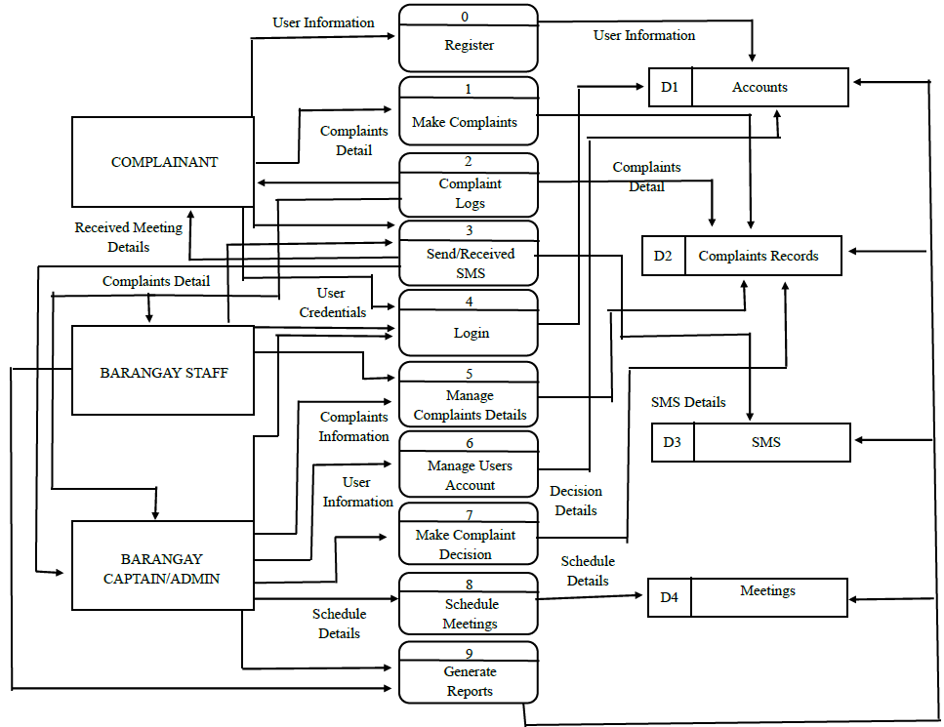

Figure 3. Data Flow Diagram of the SafeHer Case Management Process
Figure 3 illustrates the Data Flow Diagram (DFD) of the SafeHer: A Violence Against Women and Children (VAWC) Reporting System with Case Analytics, showing how data moves among the Complainant, Barangay Staff, Barangay Captain/Admin, system processes, and data stores. The process begins with user registration and login, where user information is stored in the Accounts database (D1). Complainants submit complaint details, which are recorded in the Complaint Records database (D2) and can later be viewed through the complaint logs. The system also facilitates sending and receiving SMS notifications using the SMS database (D3) to inform users about complaint updates and meeting schedules. Barangay Staff manages complaint details, while the Barangay Captain/Admin oversees user accounts, makes complaint decisions, schedules meetings, and generates reports. Meeting information is stored in the Meetings database (D4), ensuring that all schedules and case activities are properly recorded. Overall, the data flow diagram demonstrates how the SafeHer System efficiently processes, stores, and manages complaint-related information while supporting communication, case monitoring, and decision-making among all authorized users.

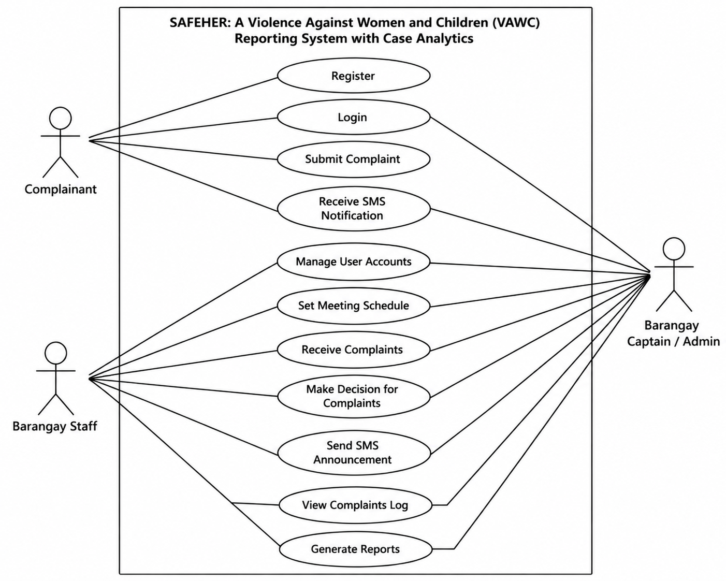

Figure 4. Use Case Diagram of SafeHer System Actors and Functions
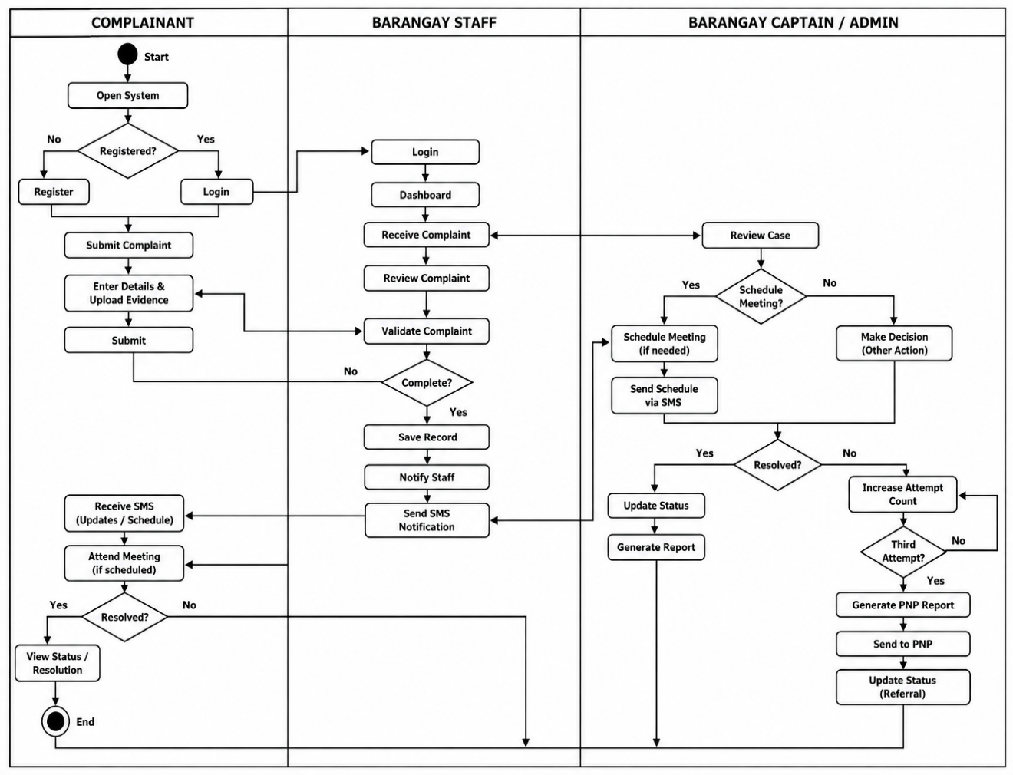
Figure 4 illustrates the Use Case Diagram of the SafeHer: A Violence Against Women and Children (VAWC) Reporting System with Case Analytics, which presents the interactions between the system and its three primary actors: the Complainant, Barangay Staff, and Barangay Captain/Admin. The Complainant can register an account, log in to the system, submit complaints, and receive SMS notifications regarding updates and meeting schedules. The Barangay Staff is responsible for managing user accounts, setting meeting schedules, receiving complaints, making decisions on complaints, sending SMS announcements, viewing complaint logs, and generating reports to assist in the complaint handling process. Meanwhile, the Barangay Captain/Admin has access to all major system functions, including user account management, meeting scheduling, complaint review and decision-making, receiving complaints, sending SMS announcements, viewing complaint logs, generating reports, and monitoring complaint activities to ensure proper case resolution. Overall, the use case diagram illustrates the functional requirements of the SafeHer System by defining the responsibilities and interactions of each actor, enabling an organized, efficient, and centralized process for reporting, managing, monitoring, and resolving VAWC cases within the barangay.

Figure 5. Process Swimlane Diagram
Figure 5 illustrates the Process Swimlane Diagram of the SafeHer: A Violence Against Women and Children (VAWC) Reporting System with Case Analytics, showing the sequence of activities and responsibilities of the three primary participants: the Complainant, Barangay Staff, and Barangay Captain/Admin. The process begins when the complainant registers or logs into the system and submits a complaint with the necessary details and supporting evidence. The Barangay Staff receives, validates, and reviews the complaint before forwarding it to the Barangay Captain/Admin for further assessment. The administrator then decides whether a meeting should be scheduled, sends SMS notifications, conducts case evaluation, and determines whether the complaint has been resolved. If unresolved, the system records the attempt and, upon reaching the third attempt, generates a referral report to the Philippine National Police (PNP). Overall, the swimlane diagram clearly defines the responsibilities of each participant and demonstrates the coordinated workflow of the SafeHer System in handling, monitoring, and resolving VAWC complaints efficiently.

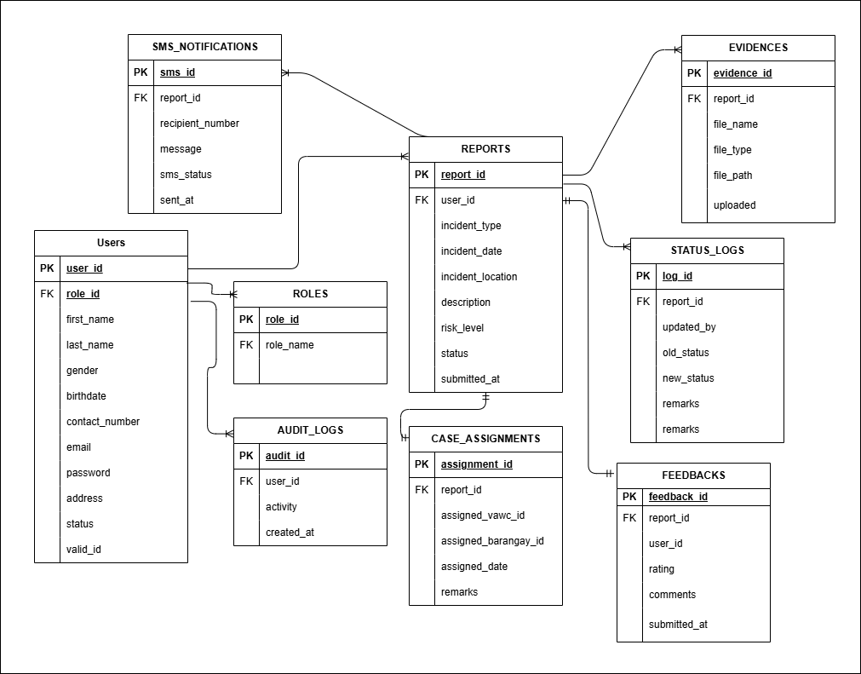

Figure 6. Entity-Relationship Diagram (ERD) of the SafeHer Database
Figure 6 presents the Entity-Relationship Diagram (ERD) of the SafeHer: A Violence Against Women and Children (VAWC) Reporting System with Case Analytics, which serves as the blueprint for the system's MySQL database. The diagram illustrates the major entities, including Users, Roles, Reports, Evidences, Status_Logs, SMS_Notifications, Audit_Logs, Case_Assignments, and Feedbacks, together with their relationships. The Users table stores the personal information and account details of complainants, barangay staff, and administrators, while the Roles table defines the corresponding user roles within the system. Each user can submit multiple reports, establishing a one-to-many relationship between Users and Reports. Likewise, each report may contain multiple supporting evidence files, status logs, SMS notifications, feedback records, and case assignments, allowing the system to comprehensively document every stage of a complaint. The Case_Assignments table records the assignment of reports to designated VAWC officers or barangay personnel, while the Status_Logs table maintains a history of status changes for monitoring case progress. The SMS_Notifications table stores message details sent to users, and the Audit_Logs table records user activities to ensure accountability and security. Overall, the ERD demonstrates how the database is structured to maintain data integrity, support efficient case management, and establish the necessary relationships among system entities through primary and foreign keys.



Complaint
Message


Web
Server
Database
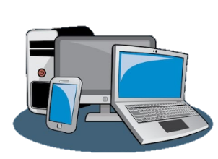

Complainant
Barangay Captain/Staff
Graphical User Interface

Figure 7. System Architecture

Figure 7 illustrates the system architecture of the SafeHer: A Violence Against Women and Children (VAWC) Reporting System with Case Analytics, showing the interaction among the system's major components. The process begins when the Complainant submits a complaint message through the system using a mobile device or web-based graphical user interface. The complaint is then transmitted to the Web Server, which serves as the central processing unit responsible for handling user requests, validating submitted information, and facilitating communication between the application and the database. All complaint records, user information, evidence, case status, and other related data are securely stored in the Database for efficient retrieval and management. The Barangay Captain/Staff accesses the system through the graphical user interface to review complaints, update case statuses, schedule meetings, send SMS notifications, and generate reports. The web server continuously exchanges data with both the database and authorized users to ensure real-time processing and accurate case monitoring. Overall, the system architecture demonstrates how the SafeHer System integrates users, the web server, the database, and the application interface to provide a secure, reliable, and centralized platform for reporting, managing, and monitoring VAWC cases.

Storyboard
The Storyboard provides a sequential visual narrative of the User Interface (UI) and the expected user experience (UX). It consists of a series of low-fidelity wireframe sketches. The sequence begins with the Landing/Login Page, flowing into the secure Complainant Dashboard. It then illustrates the multi-step Incident Reporting Form, showing how a user inputs text and uploads a file. Finally, it displays the visual Case Tracking Timeline, showing how the interface changes color or shape when a case moves from "Pending" to "Validated" to "Resolved." This ensures the developers and stakeholders agree on the system's visual layout before coding begins.
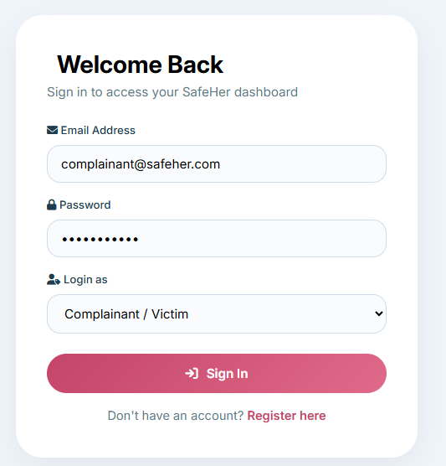
Complainant

Figure 8. Login Form for All Users
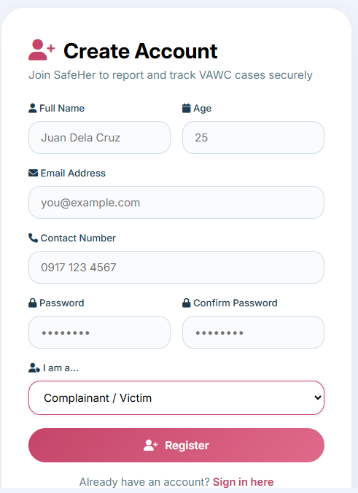

Figure 9. Resident`s Registration Form
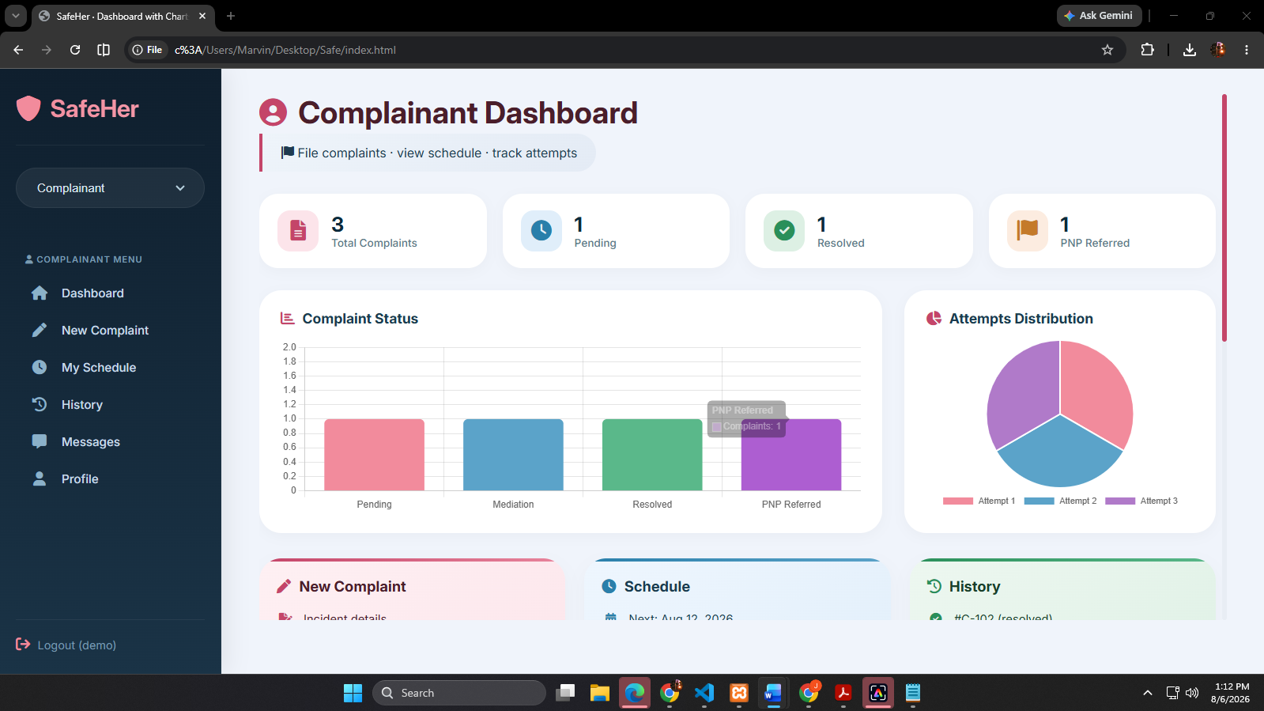

Figure 10. Complainant Dashboard Viewing and Menu`s
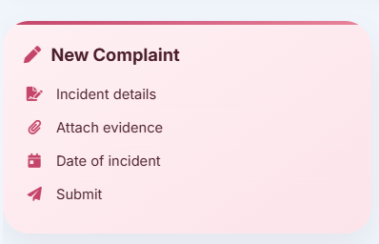

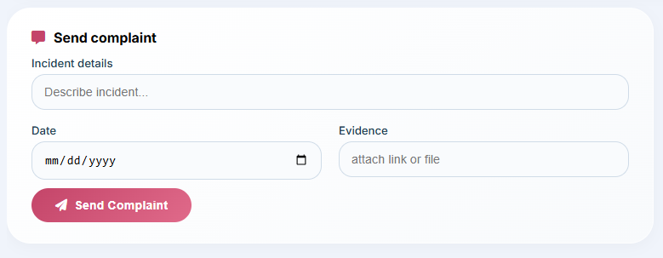
Figure 11. Complainant Form
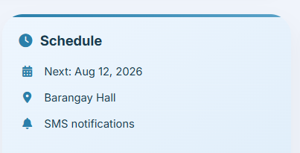

Figure 12. ReceivedBarangay Office Response

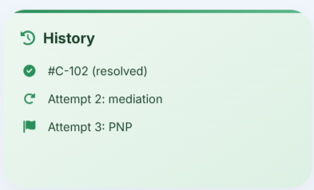

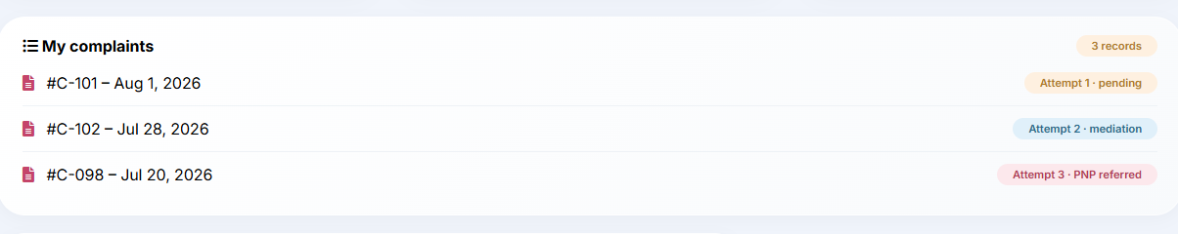
Figure 13. Complainant Complaints Log
The Complainant side of SafeHer provides a secure and accessible platform for victims to report VAWC cases without the need for physical visits to the barangay hall. The flow begins with Login and Registration, where users create an account and select their role. Once logged in, the Dashboard displays key metrics such as total complaints filed, pending cases, resolved complaints, and PNP referrals, along with visual charts summarizing complaint status and attempts made.
From the dashboard, victims can access the New Complaint feature to submit incident details and upload evidence, with the system automatically sending SMS acknowledgment. The Schedule feature allows victims to view upcoming meetings and hearings, while the History section provides a complete timeline of their case progress, including actions taken and resolution status. The Messages feature enables victims to receive SMS notifications and updates from barangay officials. Overall, the flow is designed to be mobile-friendly and intuitive, empowering victims to report abuse safely and stay informed without intimidation.
Barangay Staff
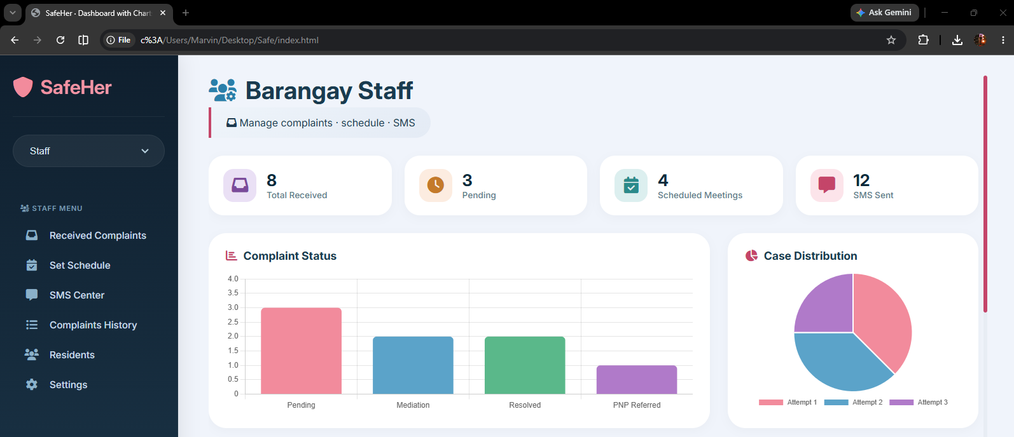
Figure 14. Barangay Staff Dashboard
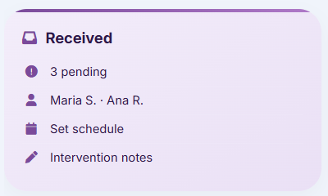

Figure 15. Receiving Complaints

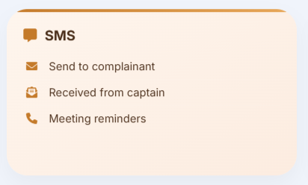

Figure 16. Sender/Receiving Announcements
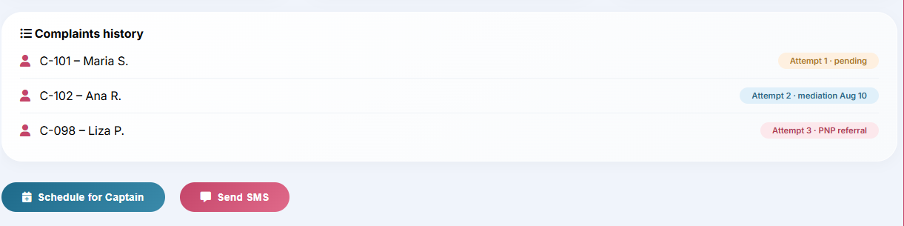
Figure 17. Viewing of Complaints History
The Barangay Staff dashboard provides a real-time overview of all incoming VAWC complaints, displaying key metrics such as total received, pending cases, scheduled meetings, and SMS messages sent. From the dashboard, staff can access received complaints to review case details, update statuses, document interventions, and track case progress. The Schedule feature allows staff to set hearing dates and coordinate with the barangay captain, while the SMS Center enables instant communication with complainants and officials. The Complaints History provides a complete timeline of all cases, ensuring accountability and proper monitoring. Overall, the system replaces slow manual logbooks with instant digital transfers, enabling faster response and better coordination.
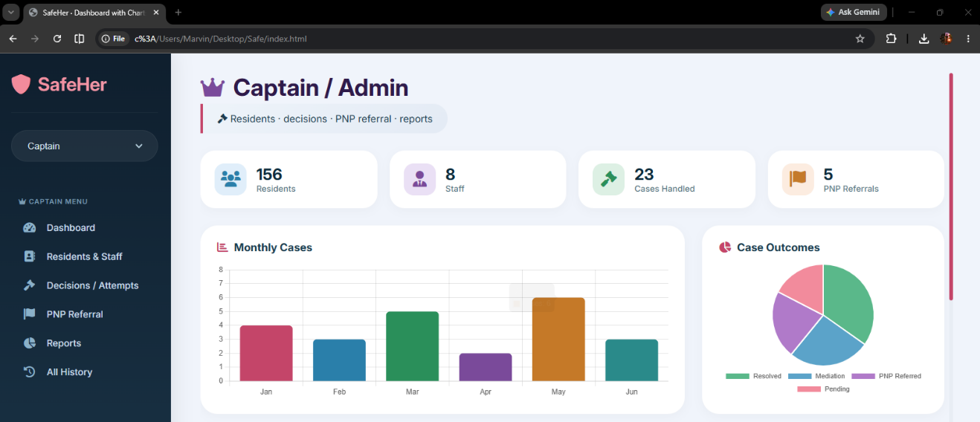
Barangay Captain/Admin

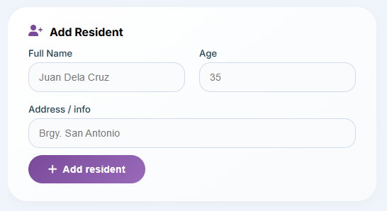
Figure 18. Admin Dashboard

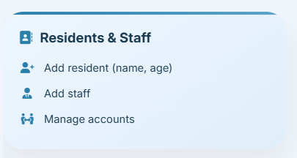

Figure 19. Admin Managing Users
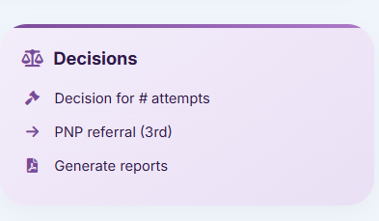
Figure 20. Admin Making Decision View for Complaints

The Barangay Captain / Admin side of SafeHer provides comprehensive tools for overseeing VAWC case management and barangay administration. Upon logging in, the Dashboard displays key metrics including total residents, staff accounts, cases handled, and PNP referrals, along with visual charts showing monthly case trends and case outcomes.
From the dashboard, the captain can manage Residents & Staff by adding resident profiles and staff accounts, ensuring accurate record-keeping and proper delegation of tasks. The Decisions feature allows the captain to document decisions based on the number of attempts made to resolve a complaint, with the ability to refer unresolved cases to the PNP on the third attempt and generate reports for accountability. The Add Resident feature enables the captain to input resident information such as name, age, and address for proper case documentation. Additionally, the captain can manage user accounts and oversee the entire system workflow.
The system empowers the barangay captain to maintain transparency and accountability, ensuring that VAWC cases are properly monitored, decisions are documented, and unresolved cases are escalated to the appropriate authorities.

Development and Testing
Software Development Method
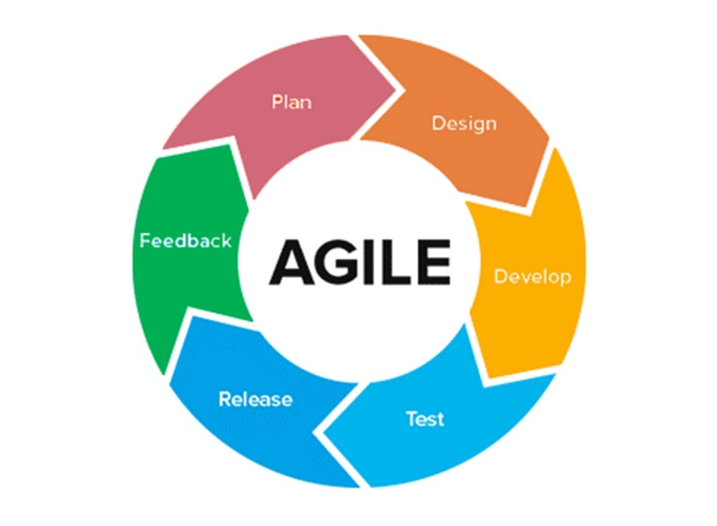
To ensure the systematic and efficient creation of the SafeHer platform, the researchers adapted the Agile Development Methodology. Unlike older methods that force developers to build everything at once before showing it to the user, Agile works in a continuous circle. This repeating loop is incredibly important for a sensitive public safety project because it allows the team to constantly build, test, and improve the software based on real-world needs.

Figure 20. Development Method

A. Plan
This step starts with gathering the system requirements. Instead of making assumptions about what the community needed, the research team met directly with barangay officials, the MSWDO, and the WCPD. In these meetings, they reviewed the actual paper logbooks currently being used to see what information must be collected. From there, they mapped out the strict privacy rules required by the Anti-VAWC Act (RA 9262), defined three clear user roles, and laid out the step-by-step process for how a case should be routed. The team identified the core modules needed for the system: Incident Reporting, Complaint Management, Scheduling, Decision Management, PNP Referral, Resident Management, Staff Management, Case Tracking, Dashboard, and SMS Notifications.
B. Design
Next, the team turned those requirements into a clear blueprint for both the design and structure of the system. For complainants, this meant creating a mobile-friendly interface with big buttons and easy instructions so that anyone in distress could use it without confusion. For barangay staff and the barangay captain, the team designed a clear dashboard that displays key case metrics, active alerts, and statistical summaries. Behind the scenes, the team built a secure database using MySQL. They added strict Role-Based Access Control (RBAC) to make sure that sensitive abuse records and uploaded photo evidence stayed fully protected and hidden from anyone without permission. The team also designed the data flow diagram (DFD) and use case diagram to clearly illustrate how data moves among the complainant, barangay staff, and barangay captain/admin, and how each user role interacts with the system's functions.
C. Develop
In this phase, the blueprints were turned into real code. The developers built the system's core functions using appropriate web development technologies. They created the digital intake forms with a responsive interface, making sure the web pages worked smoothly on any device. Most importantly, they connected the web system to the PhilSMS API, which allowed them to write code that automatically formats and sends text messages to complainants and barangay personnel the moment a case status changes or a meeting is scheduled. The development process also included building the PNP Referral module, which enables the barangay captain to digitally transfer case reports to the Philippine National Police when a complaint reaches the third attempt threshold.
D. Test
Before the system could be trusted, it went through two careful rounds of testing to make sure it was safe and fully functional. First, IT experts carried out Alpha testing, where they looked for bugs and checked if the system met the ISO/IEC 25010 standards for security, reliability, performance efficiency, and usability. Once it passed those technical checks, Beta testing began. In this stage, local officials, barangay staff, and citizen representatives acting as complainants tried out the platform themselves. This showed whether the dashboard was truly easy to use in real situations, if the SMS notifications were delivered on time, and if the PNP Referral and Decision Management features worked properly.
E. Release
After the system passed both rounds of testing, it was ready to be launched. The working version of SafeHer was moved from the local test setup to a secure cloud server so it could run continuously, day and night. Instead of rolling it out to the whole municipality at once, the team chose a careful, controlled launch. For the first trial, the system was introduced only to responders in Barangay Gogon Centro. This allowed the team to closely watch how it performed in a real community setting, ensuring that all features—from Incident Reporting to PNP Referral—functioned smoothly.
F. Feedback
Because Agile works in a continuous loop, the project didn't stop at release. In this last step, the team listened closely to the actual users. They gathered feedback through surveys and interviews with barangay officials, staff, and MSWDO personnel. If someone found a button confusing or noticed a delay in text alerts, the researchers immediately took that input and went back to the 'Plan' and 'Develop' stages. This way, the system could be constantly improved, updated, and refined until it fully met the needs of the community.
G. Evaluation
The purpose of evaluating the SafeHer system is to check how well it works, how easy it is to use, and whether it truly meets the project's goals. Because this tool is meant for public safety and crisis response, it's important to make sure it not only runs without technical errors but also serves the real needs of its users—from victims in distress to barangay administrators.
To do this, the team used the Descriptive Survey Method, a structured way of collecting both numbers and personal feedback directly from end-users, stakeholders, and IT experts. As Creswell (2021) explains, this method is effective for software evaluation because it gives a clear snapshot of user attitudes, system performance, and interface accessibility at a specific point in time.
The evaluation involved surveys, interviews, and direct observation of the system in action. The main tool was a questionnaire based on the ISO/IEC 25010 Software Quality Model, which measured the system across key areas: functional suitability, performance efficiency, usability, reliability, security, maintainability, compatibility, portability, and safety.
Data Gathering Procedure
This subsection details the systematic, step-by-step process undertaken by the researchers to collect the necessary data for evaluating the SafeHer system. The procedure encompasses securing administrative permissions, preparing the testing environment, administering the research instruments, and ensuring strict adherence to ethical and legal standards.
Preparation and Validation of Instruments
The researchers developed the evaluation questionnaires anchored on the ISO/IEC 25010 Software Quality Model, focusing on Functional Suitability, Performance Efficiency, Usability, Reliability, Security, Maintainability, Compatibility, Portability, and Safety. Before distribution, these survey instruments were presented to the capstone adviser and a panel of IT experts for content validation to ensure the questions accurately measured the system's intended metrics.
System Demonstration
To gather accurate evaluation data, the respondents needed to interact with the actual system. A scheduled demonstration was conducted at the barangay hall and the selected barangay desks. The researchers provided a brief orientation on the SafeHer platform's features, including how complainants can submit reports, how barangay staff can manage complaints, and how the barangay captain can set schedules, make decisions, and refer cases to PNP. Afterward, an alpha and beta testing session was initiated where the respondents (IT experts, barangay officials, barangay staff, and citizen representatives acting as complainants) were given temporary credentials to navigate the system, submit mock reports, validate cases, schedule meetings, document decisions, and trigger the PhilSMS notifications.
After following the system testing, the ISO/IEC 25010-based questionnaires were distributed to the respondents. To accommodate user preferences, the surveys were made available in both printed and digital formats. Alongside the quantitative surveys, the researchers conducted brief, unstructured interviews with barangay officials and staff to gather qualitative feedback regarding the system's workflow accuracy and potential areas for interface improvement.
Ethical Considerations and Data Privacy
Given the highly sensitive nature of Violence Against Women and Children (VAWC) case management, the data gathering procedure strictly observed ethical research protocols:
Informed Consent: All respondents were provided with an informed consent form detailing the purpose of the study. It was explicitly stated that their participation was entirely voluntary and they could withdraw from the evaluation at any time.
Compliance with RA 10173 (Data Privacy Act of 2012): The researchers guaranteed that all personal information collected from the evaluators (such as names, contact details, and professional designations) would be kept strictly confidential and used solely for academic purposes, in full compliance with Philippine data privacy laws.
Compliance with RA 9262 (Anti-VAWC Act): To protect actual victims, absolutely no real VAWC case files were used during the system testing and data gathering phase. The respondents were instructed to use artificially generated "mock data" (fictional names and simulated incident scenarios) when testing the reporting, scheduling, decision management, and PNP referral modules to ensure the legal confidentiality of actual barangay residents was never compromised.
Data Collation and Processing
Once all the surveys and interview notes were collected, the data was organized and prepared for calculation. The scores from the questionnaires were added up to compute the weighted mean, which objectively showed if the SafeHer system was acceptable, easy to use, and technically sound enough for the community.
Respondents of the Study
This subsection identifies the specific individuals and groups selected to participate in the evaluation of the SafeHer system. To ensure that the data gathered is accurate, relevant, and representative of the system's intended operational environment in Barangay Gogon Centro, Virac, Catanduanes, the respondents are categorized into three distinct groups based on their relevance to the research objectives:
IT Professionals: Selected for their technical expertise to rigorously evaluate the system's security, backend architecture, and reliability based on ISO/IEC 25010 standards.
Barangay Officials and Staff: Selected to test the Complaint Management, Scheduling, Decision Management, PNP Referral, Resident Management, and Case Tracking modules, ensuring the system aligns with actual barangay protocols.
Citizen Representatives: Selected to simulate the Complainant/Victim role, ensuring the Incident Reporting interface is highly usable and intuitive for non-technical users in distress.
Sampling Technique
The researchers utilized Purposive Sampling for this study. Purposive sampling is a non-probability technique where respondents are deliberately chosen based on their specific characteristics, roles, and knowledge (e.g., selecting actual MSWDO social workers and IT experts) because they possess the exact qualifications required to evaluate the system's technical and operational suitability.
Table 5. Respondents of the Study
Type of Respondent | Total Population | Sample
IT Professionals and Developers | 5 | 3
Barangay Gogon Centro Resident | 10 | 4
Designated Barangay Officials | 10 | 5
Total | 25 | 11

Statistical Tool
To accurately interpret the data gathered from the evaluation questionnaires, the researchers will employ descriptive statistics. The following statistical tools and techniques are chosen based on the research objectives to quantify the system's acceptability and performance under the ISO/IEC 25010 standards:
Frequency Count and Percentage
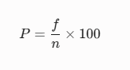
This tool will be used to analyze the demographic profile of the respondents (e.g., user roles or technical background). It determines the proportion of a specific category relative to the total number of respondents. The formula used is:

Where:
- P = Percentage
- f = Frequency of a specific response
- n = Total number of respondents
Weighted Mean
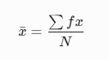
The weighted mean is the primary statistical tool used to compute the average responses from the Likert-scale questionnaires. It determines the overall rating of the SafeHer system concerning its Functional Suitability, Usability, Security, and Reliability. The formula used is:
Where:
x̄ = Weighted Mean
∑fx = Sum of the products of the frequency and the scale weight
N = Total number of respondents
Likert Scale
To quantify the subjective evaluations of the respondents, Likert Scale is utilized in the survey instruments. The computed weighted mean for each ISO/IEC 25010 characteristic will be interpreted using the specific scale and verbal descriptions outlined in the table below:
Scale | Range | Verbal Interpretation | System Quality Equivalence
5 | 4.20-5.00 | Strongly Agree | Highly Acceptable / Excellent
4 | 3.40-4.19 | Agree | Acceptable / Good
3 | 2.60-3.39 | Neutral | Moderately Acceptable / Fair
2 | 1.80 – 2.59 | Disagree | Slightly Acceptable / Poor
1 | 1.00 – 1.79 | Strongly Disagree | Not Acceptable / Failed
Table 5. Likert Scale Range and Verbal Interpretation

REFERENCES

Books
Creswell, J. W., & Creswell, J. D. (2018). Research design: Qualitative, quantitative, and mixed methods approaches (5th ed.). SAGE Publications.

Fowler, M., & Highsmith, J. (2021). Agile software development: Principles, patterns, and practices (3rd ed.). Addison-Wesley Professional.

Stauffer, M. (2019). Laravel: Up and running: A framework for building modern PHP apps (2nd ed.). O'Reilly Media.

Welling, L., & Thomson, L. (2016). PHP and MySQL web development (5th ed.). Addison-Wesley Professional.

Journals/Conferences
Anderson, B., & Smith, J. (2021). SMS-based emergency reporting systems in developing regions: Enhancing public safety. International Journal of Disaster Risk Reduction, 55, 102-115. https://doi.org/10.1016/j.ijdrr.2021.102081
Davis, L., & Clark, T. (2023). Designing trauma-informed user interfaces for reporting abuse: Usability and psychology. Computers in Human Behavior, 140, 45-59. https://doi.org/10.1016/j.chb.2022.107568
Garcia, M. A., & Martinez, R. (2021). Barriers to reporting gender-based violence in rural Philippines: An analysis of localized reporting mechanisms. Asian Journal of Criminology, 16(2), 145-162. https://doi.org/10.1007/s11417-020-09340-2

Kim, J., & Park, S. (2022). Evaluation of e-government system quality using the ISO/IEC 25010 framework. Journal of Information Technology Management, 33(4), 112-128. https://doi.org/10.1016/j.jitm.2022.04.011

Websites
Bicol Peryodiko. (2023, July 16). Alarming cases. Bicol Peryodiko.
https://bicolperyodiko.com/2023/07/16/alarming-cases/
Laravel. (2024). Laravel documentation: Routing and MVC architecture. Laravel. https://laravel.com/docs
Radyo Pilipinas Virac. (2024). Catanduanes PNP, nakapagtala ng kaso ng VAWC [Facebook post]. Facebook. https://www.facebook.com/radyopilipinasviraccatanduanes/posts/1357585413082049/
World Health Organization. (2021, March 9). Violence against women: Key facts. World Health Organization. https://www.who.int/news-room/fact-sheets/detail/violence-against-women

Other Sources
International Organization for Standardization. (2011). Systems and software engineering — Systems and software Quality Requirements and Evaluation (SQuaRE) — System and software quality models (ISO/IEC 25010:2011).
Republic Act No. 9262. (2004). Anti-Violence Against Women and Their Children Act of 2004. Official Gazette of the Republic of the Philippines.
Republic Act No. 10173. (2012). Data Privacy Act of 2012. Official Gazette of the Republic of the Philippines.

